CMPE 480 INTRODUCTION TO ARTIFICIAL INTELLIGENCE 26.11.2015

APPLICATION PROJECT

In this project, you will write a Prolog program for the following problem:

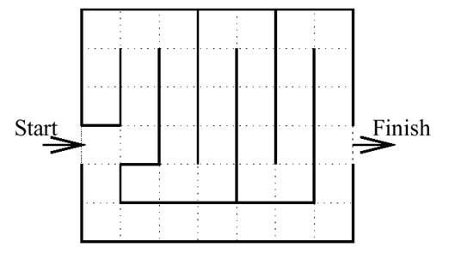
Consider the maze in the figure, in which a robot is trying to go from the start location to the finish location. The possible operators are up, down, left, and right, which are only valid if there is a dashed line between the grid boxes in the map of the maze. We want to design a program that finds a possible path from the start location to the finish location.

Write a Prolog program that uses best first search for solving this problem. The classical heuristic for this problem is the straight-line distance between the current position in the maze and the exit from the maze. Use different heuristics, solve the problem with each one, and comment on their efficiency. You must take into account both the cost from the start state to the current state (i.e. the g function) and the cost from the current state to the goal state (i.e. the h function). That is, use the f′=g+h′ function, not only the h′ function. Experiment with different heuristics. For instance, the cost of upper rows may be higher than the cost of lower rows and a possible heuristic may take this into account, thus it prefers going downward. You can estimate the h′ function in a suitable way. Use your imagination. No points will be given to the project if only the classical heuristic is used.

Given a goal, the output must show the whole path between the entry and the exit. In addition, it must show the alternative choices at each step and the backtracking points.

The row and column numbers must be given as input. You may assume that the maze always has a single entry point and a single exit point. You can use a suitable representation for the maze. You must test your program with different row numbers, column numbers, entry points, exit points, and mazes.

Notes:
- Your project will be graded on correctness, readability, testing strategy, efficiency, documentation, and the use of logic programming style.
- You must use pure logic programming style. That is, you may not use the operators and predicates like ; (“or”), -> (“if-then”), and “repeat”. An exception is that you may use the ! (cut) predicate.
- Prolog program (SWI Prolog) with some manuals and tutorials are on the course website.
- Read the Programming Projects section in the document General Information for Students link in the Syllabus. You should obey the rules for electronic submission (e-mail subject, etc.) and documentation. You must prepare a document about the project, which is an important part of the project. Explain clearly the program (predicates, parameters of predicates, etc.) and include several test cases in the document.
- The project will be done individually, not as a group.
- The strict deadline is 4.1.2016.

